**DEPARTMENT OF INFORMATION TECHNOLOGY**

**Course: Data Structures and Algorithms**

**B.Tech. (Information Technology) – Semester III**

**Academic Year: 2024-25 (Odd Semester)**

**Experiment No: 3**

**Aim:** Implementation of Infix to Postfix Expression for real-world applications.

**Objective:**

1. To introduce the concepts of data structures and analysis procedure.

2. To conceptualize linear data structures and its implementation for various real-world applications**.**

**Code :**

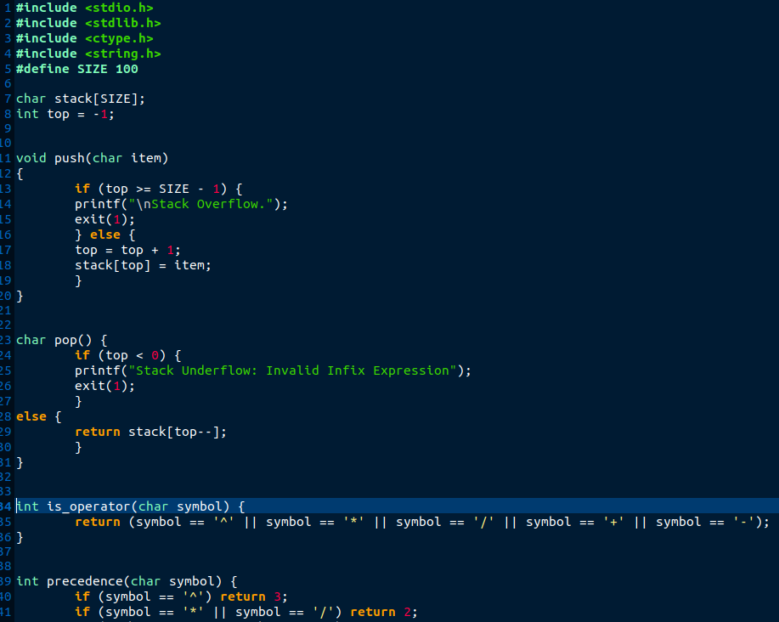

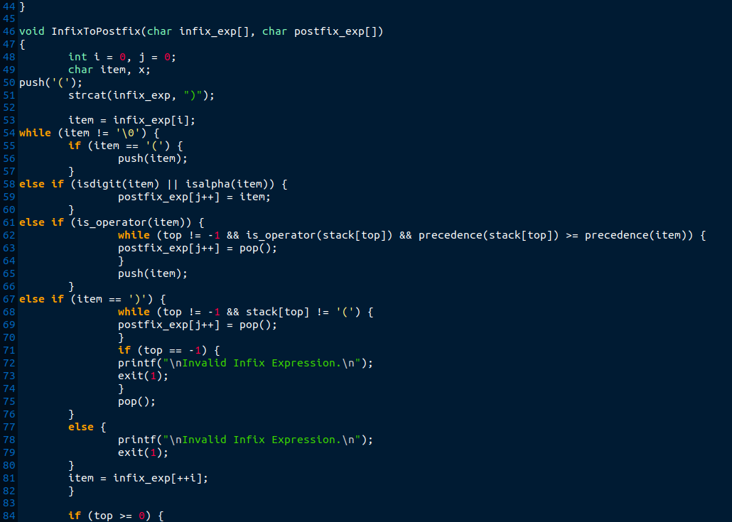

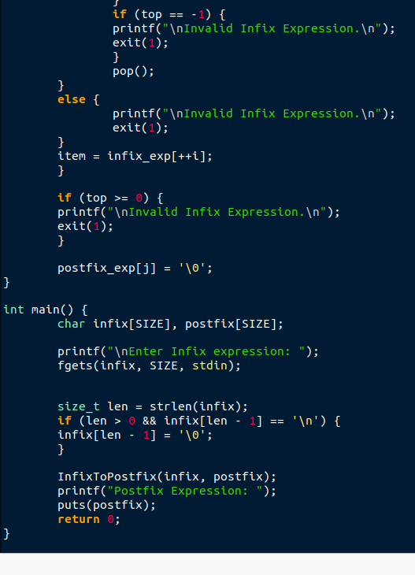

**Output:**

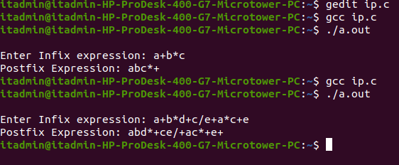

**Submitter Details:-**

**Name of Student: Veer Gokani**

**Roll No.: 30**

**Date of Performance: 16/08/2024**

**Date of Submission: 17/08/2024**

**Div/Batch :- A/S-2**